**FSD ASSIGNMENT**

**ASSIGNMENT 1:**

<!DOCTYPE html>

<html lang="en">

<head>

    <title>My First HTML Page</title>

</head>

<body>

    <h1>Harshavardhana N</h1>

    <p>My Hobbies are Coding, Playing Chess, Listening songs.</p>

    <hr>

    <br>

</body>

</html>

**OUTPUT:**



**ASSIGNMENT 2:**

<!DOCTYPE html>

<html lang="en">

<head>

    <title>Lists and Links</title>

</head>

<body>

    <h2>Favorite Fruits</h2>

    <ul>

        <li>Mango</li>

        <li>Watermelon</li>

        <li>Grapes</li>

    </ul>

    <h2>Top 3 Movies</h2>

    <ol>

        <li>KGF</li>

        <li>Sita Ramam</li>

        <li>Hi Nanna</li>

    </ol>

    <p>RCB is my favorite:

        <a href="https://www.royalchallengers.com/" target="_blank">Visit here</a>

    </p>

</body>

</html>

**OUTPUT:**

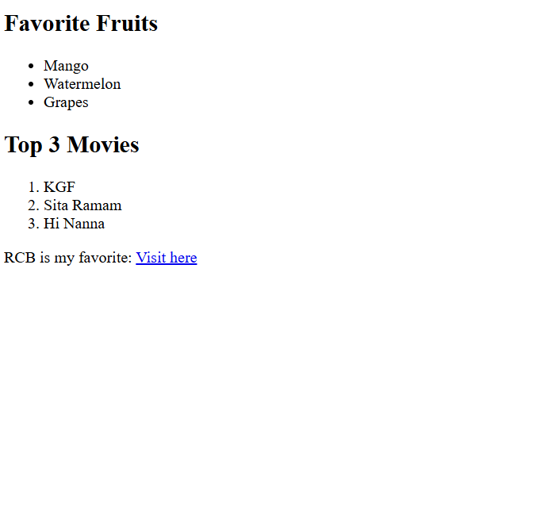

**ASSIGNMENT 3:**

<!DOCTYPE html>

<html lang="en">

<head>

    <title>Images and Tables</title>

</head>

<body>

    <h2>Sample Image</h2>

    <img src="https://akm-img-a-in.tosshub.com/indiatoday/images/story/202505/virat-kohli-273410828-16x9.jpg?VersionId=cbFeYC3ZnbCivaztzaQ4C9sacda9un3X&size=690:388" alt="Placeholder Image">

    <h2>Student Information</h2>

    <table border="1">

        <tr>

            <th>Name</th>

            <th>Age</th>

            <th>Favorite Subject</th>

        </tr>

        <tr>

            <td>Harsha</td>

            <td>24</td>

            <td>FSD</td>

        </tr>

        <tr>

            <td>Sagar</td>

            <td>22</td>

            <td>AOS</td>

        </tr>

        <tr>

            <td>Jaytheertha</td>

            <td>23</td>

            <td>Cloud comp</td>

        </tr>

    </table>

</body>

</html>

OUTPUT:

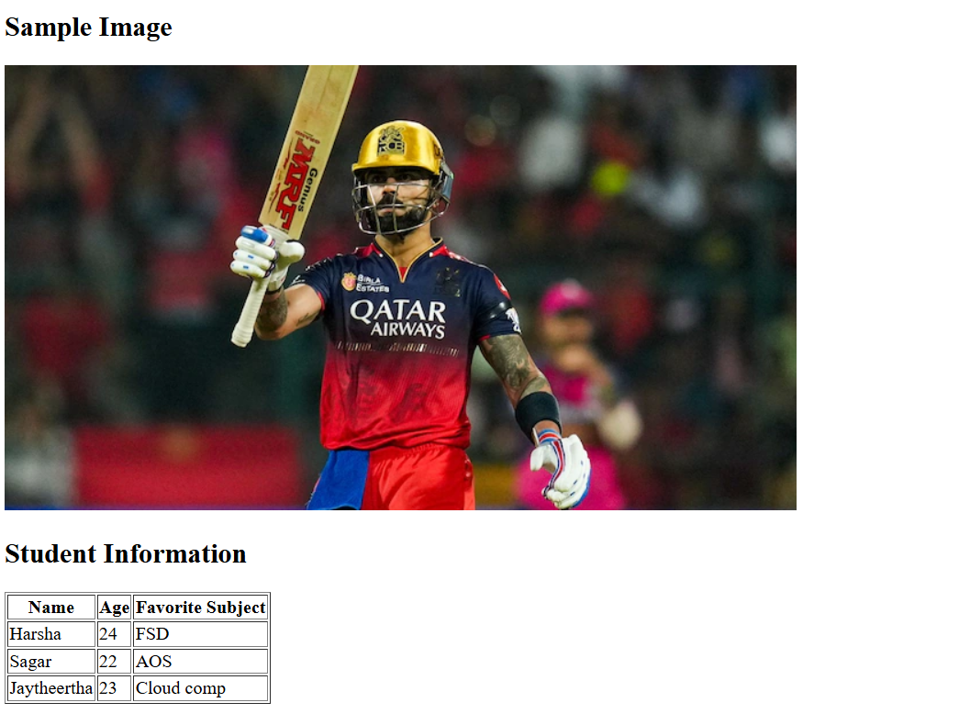

**ASSIGNMENT 4:**

<!DOCTYPE html>

<html lang="en">

<head>

    <title>CSS </title>

    <style>

        h1 {

            background-color: lightblue;

            color: darkblue;

            font-size: 30px;

        }

        p {

            font-family: Arial, sans-serif;

            text-align: justify;

        }

    </style>

</head>

<body>

    <h1>Welcome to My Page</h1>

    <p>my name is harshavardhan i am from MSRIT.</p>

</body>

</html>

OUTPUT:

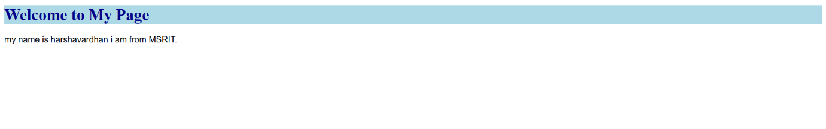

**ASSIGNMENT 5:**

<!DOCTYPE html>

<html lang="en">

<head>

    <title> Classes and IDs</title>

    <style>

        #intro {

            border: 2px solid black;

            padding: 10px;

        }

        .highlight {

            background-color: yellow;

        }

    </style>

</head>

<body>

    <div id="intro">

        <p>This is the introduction section.</p>

    </div>

    <div class="highlight">

        <p>This section has a yellow background using a class.</p>

    </div>

</body>

</html>

**OUTPUT:**

